**Assignment – 1**

**HTML**

**1. Create an HTML page and perform the following operation**

**a. Display “Web Application Development” in an h1 tag**

**b. Display “Master in Computer Application” in an h4 tag**

**c. Design a simple navbar with links to the following questions Home(Q1),List(Q2),   
 Table(Q3), Login(Q4), and Registration(Q5).**

**d. Add a bookmark on the navbar called Html to Question 1(h)**

**e. Create a hyperlink on the navbar to link google.com using an anchor tag. On click, google should open on a new tab.**

**f. Display a moving text “Happy Learning” with the yellow background color. Use different   
 attributes to control speed, behavior, and direction.**

**g. Take any image and display it on the web page. Control the height and the width of the image. h. Write a paragraph about HTML using the p tag**

**Code : Q1.html**

<!-- Name : uttam kumjar jena

Sic : 23mmci80 -->

<!DOCTYPE html>

<html lang="en">

<head>

<meta charset="UTF-8">

<meta name="viewport" content="width=device-width, initial-scale=1.0">

<title>First question</title>

</head>

<body>

<h1>Web Application Development</h1>

<h4>Master in Computer Application</h4>

<nav id="html">

<ul>

<li><a href="">Home</a></li>

<li><a href="q2.html">List</a></li>

<li><a href="q3.html">Table</a></li>

<li><a href="q4.html">Login</a></li>

<li><a href="q5.html">Registration</a></li>

<li><a href="#Html">Html</a></li>

</ul>

<a href="https://www.google.com/" target="_blank">google</a>

</nav>

<marquee behavior="alternate" direction="right" scrollamount="5" bgcolor="yellow" >Happy Learning</marquee>

<img src="../images/img.jpg" alt="" height="400px" width="600px">

<p id="Html">about html Lorem ipsum dolor sit amet consectetur, adipisicing elit. Qui, alias. Cumque, saepe corrupti unde laboriosam, eius vel est aliquid praesentium possimus adipisci quod ut! Voluptatibus natus facere esse deserunt repudiandae. Lorem ipsum dolor </p>

</body>

</html>

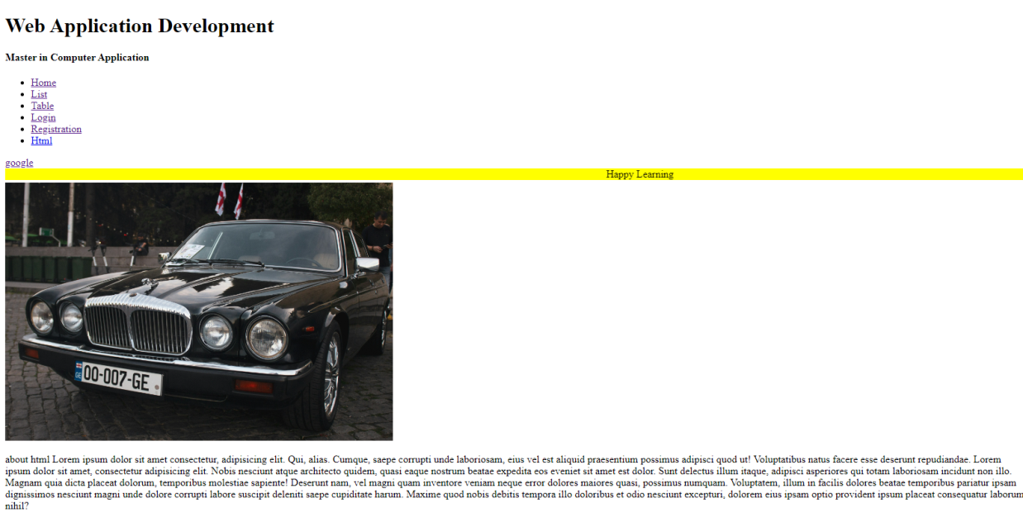**Output :**  
**2. Create an HTML page and perform the following operation –**

**Display the following unordered List –**

* **Water**
* **Milk**
* **Tea**
* **Coffee**
* **Juice**

**Display the following unordered List –**

1. **Asia**
2. **Africa**
3. **North America**
4. **South America**
5. **Antarctica**
6. **Europe**
7. **Oceania**

**Display the following nested list –**

* **Algebraic Formula**
* **(a + b)2  = a2 +b2 + 2ab**
* **(a - b)2  = a2 + b2 - 2ab**

**Co-Ordinate Geometric Formula:**

* **Distance between (x1,y1) and (x2,y2) is √ ((x1-x2)2+(y1-y2)**
* **The midpoint between (x1,y1) and (x2,y2) is ((1/2)(x1 + x2), (1/2)(y1 + y2))**

**Code:** **q2.html**

<!-- Name : uttam kumjar jena

Sic : 23mmci80 -->

<!DOCTYPE html>

<html lang="en">

<head>

<meta charset="UTF-8">

<meta name="viewport" content="width=device-width, initial-scale=1.0">

<title>Question Two</title>

</head>

<body>

<ul type="square">

<li>Water</li>

<li>Milk</li>

<li>Tea</li>

<li>Coffee</li>

<li>Juice</li>

</ul>

<ol type="I">

<li>Asia</li>

<li>Africa</li>

<li>north America</li>

<li>South America</li>

<li>Antartica</li>

<li>Europe</li>

<li>Ocania</li>

</ol>

<ol>

<li><u>Algebraic Formula</u>

<ul type="disc">

<li>(a+b) <sup>2</sup> = a <sup>2</sup> + b <sup>2</sup> +2ab</li>

<li>(ab) <sup>2</sup> = a <sup>2</sup> + b <sup>2</sup> -2ab</li>

</ul>

</li>

<li><u>Co-Ordinate Geometric Formula</u>

<ul type="disc">

<li>Distance between(x <sub>1</sub>,y <sub>1</sub> ) and (x <sub>2</sub> , y <sub>2</sub> ) is &radic; ((x <sub>1</sub> - x <sub>2</sub>) <sup>2</sup> + (y <sub>1</sub> - y <sub>2</sub>) <sup>2</sup> ) </li>

<li> The mid point between( x <sub>1</sub>,y <sub>1</sub> ) and (x <sub>2</sub>,y <sub>2</sub> ) is ((1/2)(x <sub>1</sub>+ x <sub>2</sub> ),(1/2)(y <sub>1</sub>+ y <sub>2</sub> ))</li>

</ul>

</li>

</ol>

</body>

</html>

**Output :**

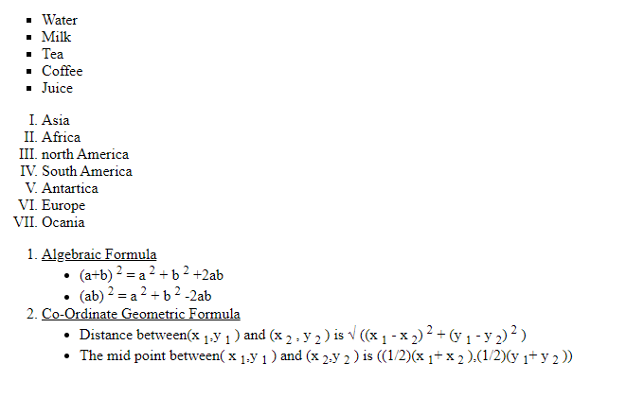

**3. Design a web page using HTML to display the following tables.**

* **Create a simple table to display the student’s information like roll number, name, mobile, email, and profile photo. Enter at least two records.**
* **Create the table as given below**

**Code : q3.html**

<!-- name : uttamn kumar jena

sic : 23mmci80 -->

<!DOCTYPE html>

<html lang="en">

<head>

<meta charset="UTF-8">

<meta name="viewport" content="width=device-width, initial-scale=1.0">

<title>Table 3rd question</title>

</head>

<body>

<table border="1" cellspacing="0" align="center">

<caption>Student <sup>'</sup>s Informatiom</caption>

<tr>

<th>Roll Number</th>

<th>Name</th>

<th>Mobile</th>

<th>Email</th>

<th>Picture</th>

</tr>

<tr>

<td>09</td>

<td>Uttam Kumar</td>

<td>8018886621</td>

<td>uttamkumarjena507@gmamil.com</td>

<td><img src="../images/user1.jpg" alt="" height="100px" width="100px"></td>

</tr>

<tr>

<td>10</td>

<td>Biswa Bishal</td>

<td>99375264</td>

<td>bbs2002@gmail.com</td>

<td><img src="../images/user2.png" alt="" height="100px" width="100px"></td>

</tr>

</table>

<br><br>

<table border="1" cellpadding="5px" cellspacing="0" align="center">

<caption> <h2>MCA 3 <sup>rd</sup> SEM Time Table </h2></caption>

<thead align="center">

<tr>

<th></th>

<th>09:50 - 10:45</th>

<th>10:45 - 11:40</th>

<th>11:40 - 12:35</th>

<th>12:35 - 01:30</th>

<th>01:30 - 02:25</th>

<th>02:25 - 03:20</th>

</tr>

</thead>

<tbody align="center">

<tr>

<td><b>MONDAY</b></td>

<td colspan="2">Consultancy Hour</td>

<td>DBMS <br>#456A</td>

<td rowspan="5"> L <br>U <br> N <br>C<br>H<br>B<br>R<br>A<br>K<br>E</td>

<td>ML <br>#456A</td>

<td>AI<br>#456A</td>

</tr>

<tr>

<td><b>TUESDAY</b></td>

<td>AI <br>#456A</td>

<td colspan="2">Python Lab <br> #456</td>

<td>AI <br>#456A</td>

<td>Cloud Computing <br>#456A</td>

</tr>

<tr>

<td><b>WEDNESDAY</b></td>

<td>Cloud Computing <br>#456A</td>

<td>ML <br>#456A</td>

<td>DBMS <br>#456A</td>

<td colspan="2">UID LAB <br>#456A</td>

</tr>

<tr>

<td><b>THURSDAY</b></td>

<td>Consultancy Hour</td>

<td>Cloud Computing <br>#456A</td>

<td>DBMS <br>#456A</td>

<td>ML <br>#456A</td>

<td>AI <br>#456A</td>

</tr>

<tr>

<td><b>FRIDAY</b></td>

<td>DBMS <br>#456A</td>

<td colspan="2">Python Lab <br> #456</td>

<td colspan="2">UID LAB <br>#456A</td>

</tr>

<tr>

<td><b>SATURDAY</b></td>

<td>Consultancy Hour</td>

<td>Consultancy Hour</td>

<td>Consultancy Hour</td>

<td>Consultancy Hour</td>

<td>Consultancy Hour</td>

<td>Consultancy Hour</td>

</tr>

</tbody>

</table>

</body>

</html>

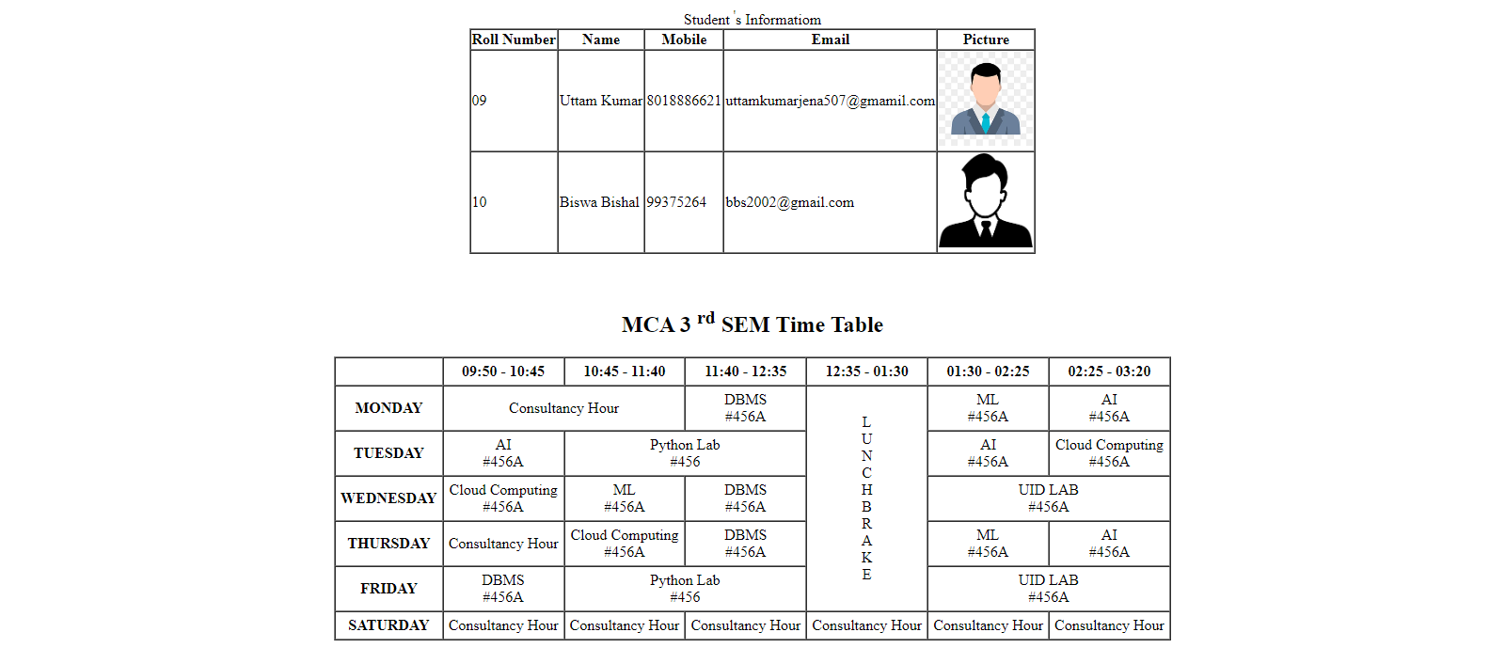**Output:**

**4.** **Design a web page to display a simple login form with email and password fields. Also, create a button for Log In .**

**Code:q4.html**

<!-- name : uttamn kumar jena

sic : 23mmci80 -->

<!DOCTYPE html>

<html lang="en">

<head>

<meta charset="UTF-8">

<meta name="viewport" content="width=device-width, initial-scale=1.0">

<title>Login Form</title>

</head>

<body>

<form action="" method="">

<label for="">Email</label>

<input type="email" placeholder="Email" name="email"><br>

<label for="">Password</label>

<input type="password" placeholder="Password" name="pass"><br>

<input type="submit" value="LogIn">

</form>

</body>

</html>

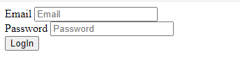**Output:**

**5. Design a web page to display the enquiry page given bellow by combining both HTML Table and Form tag. Program should have options – B.Tech, M.Tech , MCA, M.Sc. Subject should have options – CSE, CST, CEN, EIE, EE, EEE, MCA, and Data Science**

**Code :q5.html**

<!-- name : uttam kumar jena

sic : 23mmci80 -->

<!DOCTYPE html>

<html lang="en">

<head>

<meta charset="UTF-8">

<meta name="viewport" content="width=device-width, initial-scale=1.0">

<title>Document</title>

</head>

<body>

<h1 align="center">Silicon Institute of Technology</h1>

<form action="" method="">

<table border="1" cellspacing="0" align="center" width="800">

<caption>Enquiry Form 2023-24</caption>

<tr>

<td>Name : </td>

<td>

<input type="text" placeholder="First Name">

<input type="text" placeholder="Last Name">

</td>

</tr>

<tr>

<td>Father's Name:</td>

<td><input type="text" placeholder=""></td>

</tr>

<tr>

<td>Date of Birth: </td>

<td><input type="date"></td>

</tr>

<tr>

<td>Gender: </td>

<td>

<input type="radio" name="gender">

<label for="">Male</label>

<input type="radio" name="gender">

<label for="">Female</label>

<input type="radio" name="gender">

<label for="">Other</label>

</td>

</tr>

<tr bgcolor="grey">

<td colspan="2">Address & contact Info:</td>

</tr>

<tr>

<td>Adddress: </td>

<td><textarea name="" id="" cols="5" rows="8"></textarea></td>

</tr>

<tr>

<td>Mobile No:</td>

<td><input type="cel" name="" id=""></td>

</tr>

<tr>

<td>E-Mail:</td>

<td><input type="email"></td>

</tr>

<tr bgcolor="grey">

<td colspan="2">Academic Qualification</td>

</tr>

<tr>

<td>Secondary:</td>

<td>

<input type="text" placeholder="BoardUnversity">

<input type="text" placeholder="Year Of Passing">

<input type="text" placeholder="% or CGPA">

</td>

</tr>

<tr>

<td>Higher Secondary:</td>

<td>

<input type="text" placeholder="BoardUnversity">

<input type="text" placeholder="Year Of Passing">

<input type="text" placeholder="% or CGPA">

</td>

</tr>

<tr>

<td>Graduation:</td>

<td>

<input type="text" placeholder="BoardUnversity">

<input type="text" placeholder="Year Of Passing">

<input type="text" placeholder="% or CGPA">

</td>

</tr>

<tr bgcolor="grey" >

<td colspan="2">Admission Details</td>

</tr>

<tr>

<td>Program:</td>

<td>

<select name="" id="">

<option value="">Select</option>

<option value="">B.Tech</option>

<option value="">M.Tech</option>

<option value="">MCA</option>

<option value="">M.Sc.</option>

</select>

</td>

</tr>

<tr>

<td>Select Subject:</td>

<td>

<select name="" id="" >

<option value="">Select</option>

<option value="">CSE</option>

<option value="">CST</option>

<option value="">CEN</option>

<option value="">EIE</option>

<option value="">EE</option>

<option value="">EEE</option>

<option value="">MCA</option>

<option value="">Data Science</option>

</select>

</td>

</tr>

<tr bgcolor="grey">

<td colspan="2">Undertaking by Candidate</td>

</tr>

<tr>

<td colspan="2"> <p>Lorem ipsum, dolor sit amet consectetur adipisicing elit. Quaerat nobis sit dignissimos praesentium doloribus nam pariatur ducimus! Delectus, sapiente iusto nesciunt vero porro itaque tenetur dignissimos commodi inventore atque animi?</p> <br> <input type="checkbox"> I Agreed </td>

</tr>

<tr>

<td colspan="2" align="right">

<input type="Submit" value="Submit">

<input type="reset" value="Reset">

</td>

</tr>

</table>

</form>

</body>

</html>

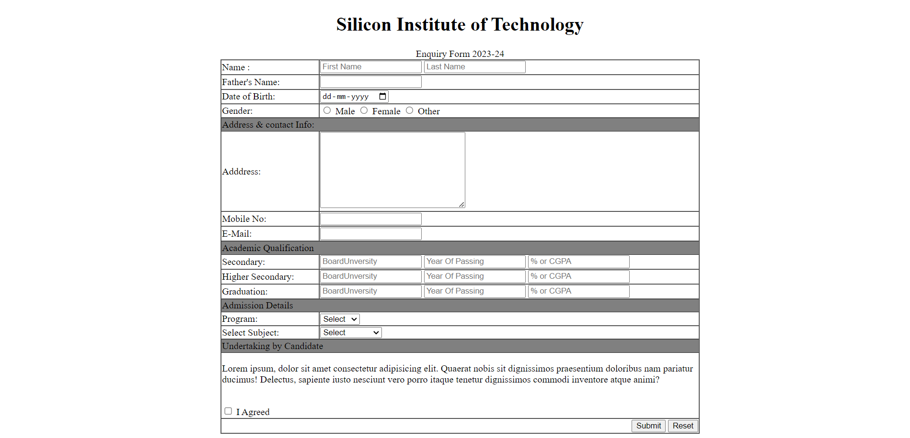**Output:**

**6 . Design a web page and perform the following operation –**

1. **Link an audio file to the html page**
2. **Display a video on the web page**
3. **Link one YouTube video onto your web page**
4. **Display the Google Map location of SIT Bhubaneswar on your web page**

**Code: q6.html**

<!-- name : uttamn kumar jena

sic : 23mmci80 -->

<!DOCTYPE html>

<html lang="en">

<head>

<meta charset="UTF-8">

<meta name="viewport" content="width=device-width, initial-scale=1.0">

<title>Question 6</title>

</head>

<body>

<audio controls>

<source src="bells.mp3" type="audio/mp3">

</audio>

<video controls>

<source src="Piper.mp4" type="video/mp4">

</video>

<iframe width="914" height="514" src="https://www.youtube.com/embed/vEkQbtPmHnk" title="Dangerous Journey to India’s Loneliest Village" frameborder="0" allow="accelerometer; autoplay; clipboard-write; encrypted-media; gyroscope; picture-in-picture; web-share" referrerpolicy="strict-origin-when-cross-origin" allowfullscreen></iframe>

<iframe src="https://www.google.com/maps/embed?pb=!1m18!1m12!1m3!1d3740.7806764633715!2d85.8037610752383!3d20.350677281134352!2m3!1f0!2f0!3f0!3m2!1i1024!2i768!4f13.1!3m3!1m2!1s0x3a1908e064769e73%3A0x9288172f3a98c7a4!2sSilicon%20University!5e0!3m2!1sen!2sin!4v1725612030630!5m2!1sen!2sin" width="600" height="450" style="border:0;" allowfullscreen="" loading="lazy" referrerpolicy="no-referrer-when-downgrade"></iframe>

</body>

</html>

**Output:**

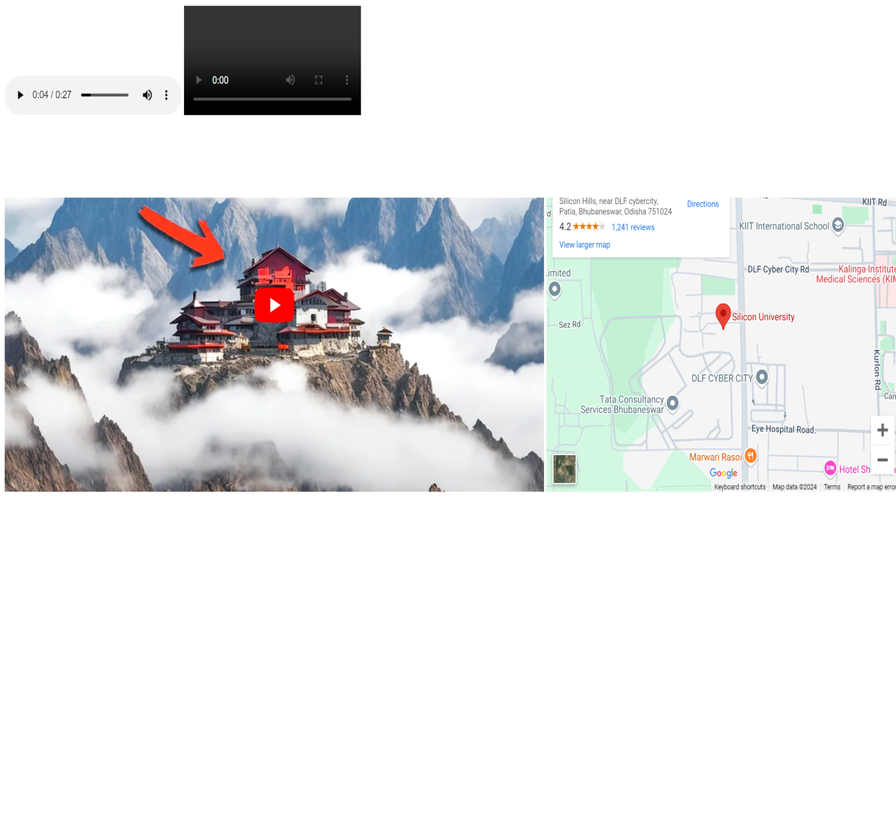

Date: 09/09/2024